

**SCHOOL OF PURE AND APPLIED SCIENCE**

**PROJECT TITLE: PATIENT MANAGEMENT SYSTEM**

**A project presented to the department of Pure and Applied Science in partial fulfillment of requirements for Degree of Bachelor of Science in information Technology at**

**KIRINYAGA UNIVERSITY**

**Submitted by:**

**NAME:** **SAMWEL MURIUKI WAMBUI**

**REGISTRATION NUMBER:** **CT100/G/7152/19**

**SUPERVISOR: DR. EDWIN IRERI**

**MAY 2023.**

# Declaration

I declare that this research proposal is my work and has not been submitted for examination in any university

Signature…………………… Date………………………………….

This research proposal has been submitted for examination with approval as the supervisor

Signature……………………. Date…………………………

# Dedication

This project proposal is dedicated to the All-Powerful God, who is my steadfast supporter and a constant source of wisdom, knowledge, and insight. I also dedicate my work to my mother, who has supported me throughout and made sure I put up the effort necessary to complete what I began. To my brothers who have been impacted by this adventure in every way imaginable. God bless you all.

# Acknowledgement

I would want to take this time to thank the Almighty God for allowing me to complete this course and for His providence. Additionally, I would like to express my profound gratitude to my supervisor, Dr. Ireri, for his crucial leadership, advice, and assistance in ensuring the success of this project.

My immediate and extended families deserve a lot of credit for their encouragement, support, and leadership. I'm eternally grateful

# Abstract

Hospitals, clinics, and health facilities currently manage and maintain vital patient information using a manual approach. Numerous paper forms are necessary under the current approach, and data is dispersed throughout the hospital infrastructure. Frequently, the data is inaccurate and does not adhere to hospital management guidelines. Forms are frequently misplaced when being transported from one department to another, necessitating a thorough auditing procedure. The hospital may have multiple copies of the same information, which could cause inconsistent data across different data repositories. Any hospital's daily operations include the gathering, handling, and quick retrieval of a massive number of data. Personal information about the patient, medical history, staff information, and other faculties may be included in this material. The management of all this data must be effective and economical. Patient management system has automated the management of patient and all faculties making it more efficient and prone to error. Review of systems that have been created and performed well was done to assist in the research. Example of the reviews are MediAfrica app, Equity Afia, health Tap, Afya service, vezeeta doctor system and Byon8. The researcher has used waterfall method of methodology, which effectively and efficiently copes with changing prospects of the new system. The methodology is flexible in analyzing requirements and enables to handle the early process of the stages of the requirements of the project. The idea is also to develop a system that can be used to keep track of the patient registering in a hospital.

**Table of content**

Declaration II

Dedication III

Acknowledgement IV

Abstract V

Abbreviations X

CHAPTER ONE: 1

1.1 Introduction 1

1.3 Current systems 3

1.5 Proposed system 3

1.6 Purpose of study 3

1.7 General objective 4

1.8 Objectives: 4

1.9 Justification 4

1.10 Scope 4

1.11 limitations 5

1.12 significance of the study 5

1.13 Definition of terms 6

CHAPTER TWO: LITERATURE REVIEW 7

2.1Introduction 7

2.2Review of Existing Systems 7

2.2.1MedAfrica 7

2.2.2 Equity Afia 8

2.2.3 Health Tap 9

2.2.5 Vezeeta Doctors System 10

2.2.6 Byon8 11

2.3 Research Gap 12

2.4 Context Diagram 13

2.5 Conclusion 13

CHAPTER 3: METHODOLOGY 14

3.1 Introduction 14

3.2 waterfall 14

3.3The sequential phases in waterfall model are: 15

3.3.1 Justification of using waterfall method to develop a system. 16

3.4 Data collection methods. 16

3.4.1 interview 16

3.4.2 observations 16

3.5 Data analysis 17

3.6 Conclusion 17

CHAPTER FOUR: SYSTEM DESIGN. 18

4.0 Introduction 18

Desktop computer/personal laptop 18

Flash disk 19

4.1.1 Software Requirements 19

4.2 Functional requirements. 20

4.2.0 User 20

User login 20

Register new users. 20

Requesting for a service 20

4.2.1 Admin 21

Manage users. 21

Non-functional requirements 21

i. Efficiency requirements. 21

ii. Reliability requirement. 21

v. Implementation requirements. 21

vi. Delivery requirements. 21

CHAPTER FIVE: SYSTEM TESTING AND IMPLEMENTATION 33

5.1 Introduction 33

5.2 System implementation 33

5.3 System testing 35

5.3.5 Database testing 39

5.6 System homepage and other relevant pages 40

5.6.0 Home page 40

5.6.1 Login page 41

5.6.2 Sign up page 42

5.6.3Add new patient page 43

5.6.4 Systems side bar 44

5.6.5 Patients 46

5.6.6 Served patients 46

5.6.7 Users 47

5.7 Conclusions 47

CHAPTER SIX CONCLUSSIONS AND RECOMMENDATIONS 48

6.0 Introduction 48

6.1 Conclusion 48

6.2 Recommendation 48

6.3 Scope for future work 49

Appendices 52

Budget 52

Gantt chart 53

**List of figures**

*Figure 1: MedAfrica app* 7

*Figure 2: Equity Afia System* 8

*Figure 3: HealthTap app* 9

*Figure 4: AfyaServe Hospital Management System* 10

*Figure 5: Vezeeta Doctors System* 11

*Figure 6: Byon8* 12

*Figure 7: Context Diagram* 13

*Figure 8: Diagrammatic Representation of the Waterfall Model* 14

*Figure 9:*  *Context level Diagram* 25

*Figure 10: use case diagram* 26

*Figure 11: sequence diagram* 27

# Abbreviations

CSS - cascading style sheets

PHP – hypertext preprocessor

HTML – hypertext markup language

SQL – structured query language

# CHAPTER ONE:

# 1.1 Introduction

A patient management system has the following advantages: streamlined operations, increased administration, control, superior patient care, strict cost control, and increased profitability (Fan et al., 2018). This technology, which is strong, adaptable, and easy to use, is designed to give hospitals practical advantages. In order to meet the demands of Kenya's medium-sized and large-sized hospitals, the patient management system is created specifically for them. The system database will make it easier to use and scalable, and all required modules and features will be created expressly to satisfy the demands of hospital patients. Because of the system's high degree of adaptability, it is going be modified to satisfy the needs and requirements of our varied patients. All required modules, including those for patient registration, doctor information, pharmacist information, served patients information and prescriptions details, are present in the system.

**1.2 Background**

Hospitals, clinics, and health centers are vital components of our life since they offer us medical services for a range of illnesses. Climate change, stress, poor food, and many forms of accidents may all contribute to the need for medical examinations and treatment. The development of health information technology has improved patient care, reduced medical errors, raised the standard of care, and provided better information to patients and clinics around the world. It is essential for a hospital to keep tabs on all of the daily activities of its patients, physicians, nurses, and other staff members (Fan et al., 2018). Keeping track of the activities on documents is exceedingly time-consuming, error-prone, and inefficient. The old method of keeping records on paper is not always reliable; if any files are damaged, all of the records would be lost, which would be quite expensive for a hospital. Patient management is the term used to describe communication between the patient and the medical staff. It comprises dialogue, empathetic listening, examination, assessment, diagnosis, and interventions. Furthermore, Arasteh et al. (2018) assert that access to healthcare affects people's quality of life and capacity to contribute to society. Healthcare errors may have a significant impact on a person's ability to participate in social and productive activities. The hospital receives a large number of daily visitors, making the existing approach unstable because it takes longer to enter data, access data, and keep paper records. The desire to be among the first group to see the doctor frequently causes a large number of patients to leave their homes quite early in the morning. Otherwise, they risk wasting the entire day by not paying attention. Most patients find this scenario disheartening, and some decide to self-medicate or use other non-professional treatments in an effort to heal quickly. Any healthcare firm that does not employ paperless healthcare solutions will fall behind the rest of the industry as they are no longer avoidable. The healthcare facility will be more successful the sooner a health information system is deployed (Nugraheni et al., 2021). Although new technological advancements, like the use of the internet and other communication methods, offer great potential in the flow of information between providers and recipients regarding the provision and management of healthcare services, the Kenyan health sector is lagging in taking advantage of such advancements to improve reporting. Health professionals rarely use health data for planning and decision-making in the delivery of services, despite the enormous resources spent on its development and distribution. The primary goal of this initiative is to offer improved, paperless services to the hospital. Additionally, this system offers security for medical data storage as well as reliable storage and backup options.

# 1.3 Current systems

Existing system cannot download the latest updates and there is risk of management of patient data when the system is under development. There is no proper coordination between different users and the current system is not user friendly.

**1.4 Problem statement**

The problem identified was the high congestion of patients in most hospitals and highly spreading severe pandemics (e.g COVID-19, high fever). Inconveniences and time loss come from the slow retrieval of historical data, such as patient histories, which require the user to search through numerous files and registers. Another issue found is manual calculations that are prone to error.

# 1.5 Proposed system

The proposed system is focusing on the welfare and good care of patients in hospitals. I have designed the system to input patient details and taking the patient through the process from registration to pharmacist and also keep patient details for future use. The proposed new system is going to store and retain all databases pertaining to patients at a central point. The system is going to be extremely fast, has perfect accuracy and saves on time. The enormous work will be done by fewer individuals. The proposed system will include information on every previous doctor, pharmacist and patient for future reference. The most advantage of this system is that it is going to decrease data duplication within the data stored. The proposed system is going to reduce the data store’s burden by facilitating regular products updates and presenting them with the relevant details, as well as financial transaction administration.

# 1.6 Purpose of study

To reduce poor health care services delivery which can lead to long queues, delayed decision making poor record keeping of patients record and this can lead to

patients turning away from the hospital due to ineffective services.

# 1.7 General objective

The main objective of this project is to create a system that would prioritize the welfare of the patient by fostering communication with the medical staff.

# 1.8 Objectives:

1. To develop a system that captures patient details.
2. To design a patient module where doctors can monitor the patient they are attending and monitor patients details.
3. To implement and test a module that will allow the pharmacist to access the doctor’s prescription for a given patient.

# 1.9 Justification

The purpose of this study project is to develop a system that will use less paper to facilitate data storage, access to the data, and retrieval while also enhancing customer services through time savings. Therefore, this research is going to help medical facilities in improving their service quality and this will influence all health care facilities to improve their system by adopting this system.

# 1.10 Scope

A patient management system is the proposed system. The system is going to be utilized in all healthcare facilities, including hospitals, clinics, and dispensaries, to collect patient information and store it for later use. The system now in use is a paper-based or traditional system. It moves too slowly to deliver an updated patient list in a timely manner. This technique aims to decrease overtime pay while increasing the number of patients who can receive precise care.

**1.11 limitations**

1. Time constraints for the amount of time for carrying out this research is limited.
2. Limited access to information as most of the respondents who are patients and other staffs in a hospital are not easily available.
3. The resources availability in implementing the system.

# 1.12 significance of the study

Patients must participate in the study because the system is going to ensure that they obtain medical information promptly and accurately. If they needed to examine their clinical record, they wouldn't have to go through a difficult process. The hospital, especially the pharmacy and billing department, would not handle many paper papers when it came to transactions and financial reporting. The employees value the research since it will enable them to enter, edit, delete, and locate information in this system. The hospital is going to benefit since it will enable them to improve administration by integrating their current computers into a single system. Overall, because it will be utilized as a tool to maintain the facility's efficiency and service quality, this study is crucial to the hospital and its patients. The operation of the health system depends on the creation and application of high standard health data and information at all levels. Based on the findings of this study, a patient management system will be evaluated in order to determine its strengths and shortcomings in terms of improving the performance of the healthcare system. The study is to act as a springboard for further investigation into the administration of health services based on evidence in general as well as the generation of fresh concepts for improved and more effective management of healthcare facilities across the nation. This research is looking at how hospitals information systems are used in both commercial and public hospitals. The report's findings would support the ministry of health's ongoing efforts to improve medical management operations systems that would benefit facilities and healthcare workers by identifying their areas of weakness and suggesting effective solutions that could improve their performance through better information use.

# 1.13 Definition of terms

1. **Data**- This information can be stored and sent as electrical impulses, and it can also be mechanically, optically, or magnetically recorded.
2. **Database**- This is a structured collection of information kept in a computer, especially one with several access points.
3. **System**- Is a group of cooperating or related parts that adhere to a set of rules to produce a logical whole.
4. **Patient** – A person who is getting or is enrolled to access medical care treatment.
5. **Doctor** – An individual qualified to examine and treat patients medically.

# 

# CHAPTER TWO: LITERATURE REVIEW

# 2.1Introduction

Several of the current health management systems are examined in this chapter. It contrasts various systems, demonstrates the remaining gaps, and shows how the loopholes may be closed by putting the suggested health management system into place.

# 2.2Review of Existing Systems

## 2.2.1MedAfrica



*Figure 1: MedAfrica app*

An app called MedAfrica, with its headquarters in Nairobi, makes essential health information more easily available on mobile devices. The portal offers data including doctor and hospital directories, drug authenticators, and symptom lists with self-diagnosis advice. This kind of symptom screening could be very helpful in nations like Kenya, where there are only 14 doctors for every 100,000 people. Members of MedAfrica say that customers are happy to pay for the service because it offers clients such crucial information and suggests qualified doctors and reliable, lab-tested medications (Actualize, 2021).

### 2.2.2 Equity Afia

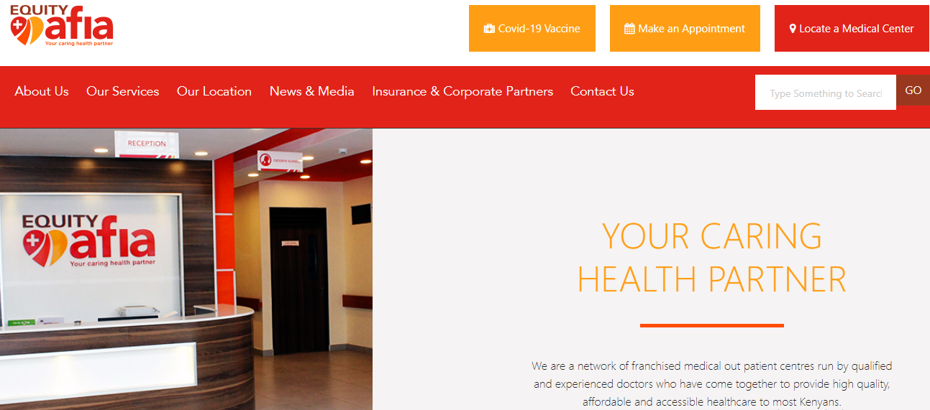

*Figure 2: Equity Afia System*

Equity Afia is a long-term, integrated health strategy that use franchising principles to educate and oversee a network of Medical-Entrepreneurs in Kenya to deliver uniform, high-quality, and inexpensive healthcare. The system is made up of a collection of trained and experienced doctors who have banded together as a medical entrepreneur network with the goal of delivering high-quality care (Equityafia.co.ke. (n.d.)).

### 2.2.3 Health Tap



*Figure 3: HealthTap app*

HealthTap is an app that gives you access to doctor-curated health information as well as a Virtual Consult feature that lets you chat to a doctor through video, audio, or text. You can obtain help on the internet or on your smartphone, where you may upload images and test results and receive instant answers, therapy, and referrals (HealthTap, n.d.).

**2.2.4AfyaServe Hospital Management System**



*Figure 4: AfyaServe Hospital Management System*

AfyaServe, a next-generation hospital administration system, seeks to simplify healthcare center procedures in Africa by providing superior technologies at low costs. In addition, by creating accurate and fast health reports, their specialized Lab Information System (LIS) aids clinical decision-making. The system hosts data for different hospitals depending on the services provided by respective hospitals (AfyaServe, 2020).

### 2.2.5 Vezeeta Doctors System



*Figure 5: Vezeeta Doctors System*

Vezeeta is the leading provider of healthcare software as a service (SaaS). It is a pioneer in the preservation of databases for various health professions. It allows for automated physician, clinic, and hospital bookings, making healthcare in the region more accessible. Patients may use the app to find, compare, book, and rate the finest doctors in their area (vezeeta.com, n.d.).

### 2.2.6 Byon8

Byon8 was formed in 2015 with the purpose of digitalizing healthcare on an individual level to make high-quality healthcare more accessible, inexpensive, and equitable. Byon8 connects you with professional physicians. It enables users to describe their symptoms and receive an accurate diagnosis. A paid video chat feature is provided on the application (*Online doctors and free symptom checkups*. byon8, n.d.).****

*Figure 6: Byon8*

## 2.3 Research Gap

Nowadays, an electronic filing system is required due to the ongoing development of technology (Al-Sharhan et al., 2019). Having a large database that can manage all types of data in one file enhances productivity, efficiency, and the maintenance of high-quality care. The value of electronic health records, which are now a requirement in healthcare facilities, is that they can aid in preventing mistakes like erroneous information, duplication medical invoicing, and denial of claims for duplicate services. The gaps revealed in the existing systems include;

1. Most of the systems analyzed are focused on providing database for specific services to patients or clients (Hospitals). For example, Vezeeta and HealthTap records doctors’ information which is later shared to patients for booking specific specialists.
2. Some systems like AfyaServe Hospital Management System provides services and manages the data for various different hospitals. This might compromise the security and privacy of patient’s data, as the hospitals do not have total control of their database. This is also expensive to medium hospitals.
3. The proposed idea aims to integrate a full-fledged hospital information management system that will make hospital operations and data preservation faster, easier, and more meaningful. By automating routine tasks, this database Application System will help to maximize employee productivity. It is possible to keep track of how many employees are on the job at any given time, assess their performance, and improve employee coordination. A hospital information management system also allows employees to access and retrieve data quickly and accurately (Salomi, & Maciel, 2017). The proposed hospital management software will ensure data confidentiality and privacy of patients and staffs, which is critical in the highly sensitive healthcare business as hospitals will have total control of the system.

## 2.4 Context Diagram

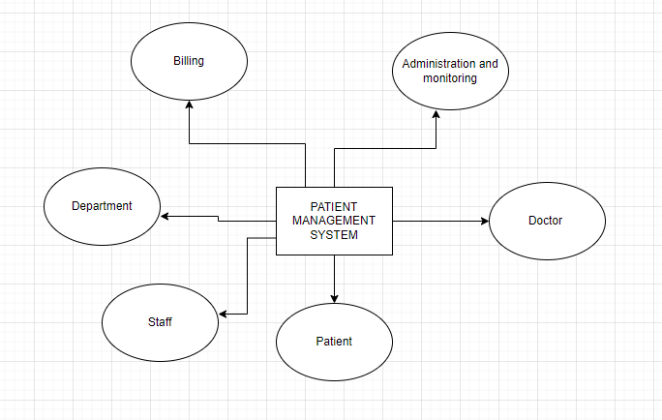

*Figure 7: Context Diagram*

## 2.5 Conclusion

By adopting the Patient Management System project, the operation becomes very easy and saving a huge amount of time because the system is vital for maintaining details about the Doctor, Patient, Hospital personnel, Bills, W (Mahmudova, 2019). Administrators at hospitals would be capable of improving operational control and hence improve operational efficiency. Since it automates the method of acquiring, compiling, and retrieving patient data, this would allow for a faster reaction time to the needs of patient care.

# CHAPTER 3: METHODOLOGY

## 3.1 Introduction

The term "system methodology" describes the process of breaking up the software development process into distinct phases, including steps to make administration and planning easier (kumar, 2018). As a result, it is generally considered to be a stage in the development process' life cycle.

## 3.2 waterfall

In the software development process, the waterfall method is a sequential (non-iterative) design phase (Kramer, 2018). Its foundation is the notion that the steps of conception, initiation, analysis, design, building, testing, production, and maintenance move progressively downhill (like a cascade). A certain set of clearly defined duties must be carried out during each stage of the life cycle.

*Figure 8: Diagrammatic Representation of the Waterfall Model*

Analysis

Design

Implementation and coding

Testing

Maintenance

## 3.3The sequential phases in waterfall model are:

Requirement gathering and analysis- This focus mainly is on mainly understanding the complete system requirement. The feasibility of the project as the basis for it to continue, all information will be collected (Hidayati, 2020), where research was made to grasp more information about my topic.

1. **System analysis**-involves analyzing and evaluating software and hardware systems. This can include evaluating the system's design, functionality, performance, reliability and requirement gathering.
2. **System design**- after the requirement gathering, the system design aids in defining the overall system architecture, the interface, and the hardware and system requirements. Diagrams will be made to design the full overview of the system. In the end of this phase a full prototype of the planned system will be designed.
3. **Implementation and coding**- in this phase, translation of all design specification in to a code will take place. It will be implemented using the html, css and JavaScript for writing functionality and MySQL for the database.
4. **Integration and testing-** The fact that project development will be done in modules, together with integrating and testing those modules, will become the next crucial factor. The emphasis is on testing each device separately and for compatibility with other brands (Kyremeh, 2019). After that, they will be combined to create the new system as a whole.
5. **Deployment of the system**- The system will be installed for use by the end users after being finished, tested, and determined to meet both the functionality and non-functionality requirements
6. **Maintenance-**There is no system that is flawless. So, when can we anticipate the system change**s**, and as a result, maintenance practices will be of great importance in ensuring the continued performance of the system. This will include updating the system within time as technology evolves.

### 3.3.1 Justification of using waterfall method to develop a system.

1. The waterfall approach is preferred since it allows for adjustments and allows for their implementation during the maintenance stage (Kyeremeh, 2019).

2. The waterfall approach is straight forward and easy to grasp and use for both the programmer and other clients.

3. In the waterfall approach, steps will be and finished sequentially, ensuring that no phase overlapped (Kyremeh, 2019).

## 3.4 Data collection methods.

I have visited a medical clinic and a hospital then compare the information I found online to the real world to see if there were any differences and to ensure that it was correct, using observations to support the best outcomes.

### 3.4.1 interview

I have interviewed doctors and other staffs to understand a greater understanding of their daily obligations, interpersonal interactions, and how the ecosystem functions in general. Frequently, processes are determined and the system is designed to serve the user using the how and what questions (Barrett & Twycross, 2018). Concrete information is acquired to support the specs and seek during mentioned interviews.

### 3.4.2 observations

A combination of interviews and observations will help understand the processes that take place during hospital operations. This will aid in determining the specifications to be included in the database system.

## 3.5 Data analysis

After collecting the required information using the different data collection techniques, data will be analyzed. This is to find out how the user wish the system to function and whether a new system will be in a position to fill the gap left by existing systems. To remove the shortcomings of a manual system, contradictions and irrelevant requirements, an analysis of data is vital.

## 3.6 Conclusion

The software development approaches that will be applied in the creation of a patient management system are the main topic of this chapter. Throughout the entire process, a waterfall model will be employed, specifically feature driven development, where the features are given more attention.

# CHAPTER FOUR: SYSTEM DESIGN.

## 4.0 Introduction

This chapter focuses on the system requirements, input form, process design and the output of the system. It contains requirements, context level diagram, input design, output design, database design for customer and administration and process design. This chapter is also aimed at explaining what the system platform can be able to do and the system requirements to be undertaken in the system. The system provides a user-friendly environment for the users.

**4.1** System requirements

requirements analysis and specification are concerned with the identification of the basic function of the software components. It relates to getting the requirement and the various specifications, which are required for developing particular software. The software and hardware requirements for this system has been discussed below:

**4.1.0** Hardware Requirements

Consist of hardware requirements to be met in order to successfully run the patient management system.

## Desktop computer/personal laptop

To be used for design and development of the system. The computer had these specifications:

1. Intel® Pentium® processor (or equivalent) with a speed of 2.50GHz
2. A RAM at least 2GB.
3. 250 GB Hard Disk Drive

UPS (uninterruptable power supply)

**For power backup with the following specifications:**

Output Power Capacity- 1920 Watts / 1920 VA, Max Configurable Power- 1980 Watts / 2200 VA, Nominal Output Voltage- 120V, output current- 8.3 Amps, output load power factor 0.6, output voltage 120Vac, input voltage 120V input power factor 0.9

## Flash disk

Used as a storage device for materials which were obtained from the internet and transferred to the working environment.

### 4.1.1 **Software Requirements**

To successfully run the patient management system, a number of software requirements had to be met which were:

**Operating System**: Windows 10 or higher versions of OS (either x86 or x64)

Act as the link between hardware and software programs.

**Microsoft Office 2010, 2013,2016, 2019 or higher**

Provided services like Microsoft word for document writing.

**Antivirus**

Used to protect the system from virus attacks.

Examples are SMADAV and Kaspersky in windows and ClamAV and ClamTk in linux.

**Database Management System: MS SQL server, MySQL Server**

A database to store the details of various users’ details, admin details among other important information of the system.

**Programming languages**

HTML, JavaScript, CSS, PHP, My SQL are going to be used to build up the website and ensure its functionality.

## 4.2 Functional requirements.

### 4.2.0 User

### User login

This feature is used by the user to login into system. A user must login with his user’s name and password to the system after registration. If they are invalid, the user is not allowed to enter into the system. Username and password will be provided after user registration is confirmed. The password should be hidden from others while typing it in the field.

### Register new users.

A new user will have to register in the system by providing essential details in order to view the services offered in the system. System must be able to verify and validate information. - The system must encrypt the password of the patient to provide security.

### Requesting for a service

The patient can request for different medical services offered in the system. The patient can also book for a doctor on his/her convenient time and day. A patient can also request for availability of different medicines and drugs available in the system. Functional requirement is that the system must ensure that, only a registered customer can purchase items.

## 4.2.1 Admin

### Manage users.

The administrator can add user, delete user, view user and block user reported as fraud in the system.

### Non-functional requirements

1. Efficiency requirements.

When a patient management system has been implemented the patient can get medical services in an efficient manner.

1. Reliability requirement.

The system should provide a reliable environment to all its users. All requests and bookings should be reaching to the admin without any errors, interruptions and modifications from outsiders.

1. . Usability requirements.
2. The patient management system is designed to have a user friendly environment and ease of use to all its users.
3. Implementation requirements.

Implementation of the system using CSS and html in front end with PHP as back end and it will be used for database connectivity. And the database part is developed by MySQL. Responsive web designing using bootstrap is used for making the website compatible for any type of screen.

1. Delivery requirements.

The whole system is expected to be delivered in four months of time.

**4.3 input design**

In any organization, institution, or system of operation, there is always an input into the system which keeps the system running. Wrong input results in wrong output.

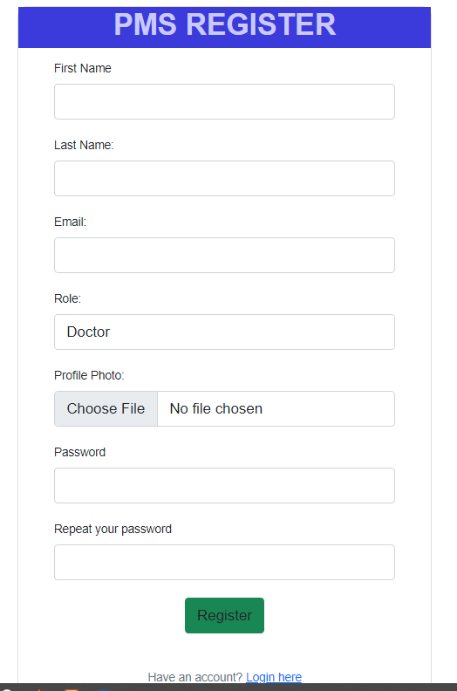

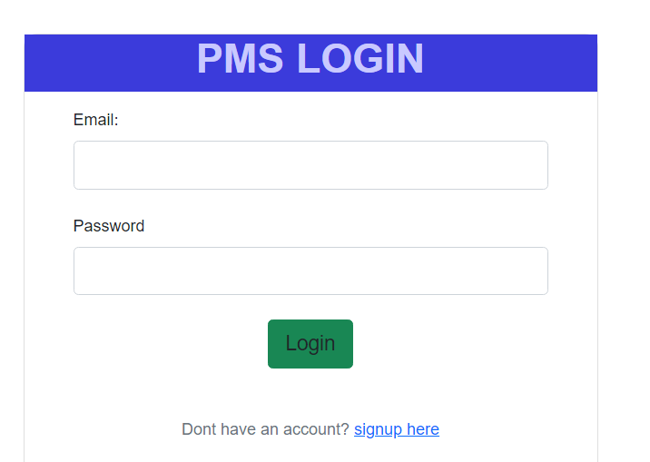

**4.3** Process design

**4.3.0** Context level diagram.

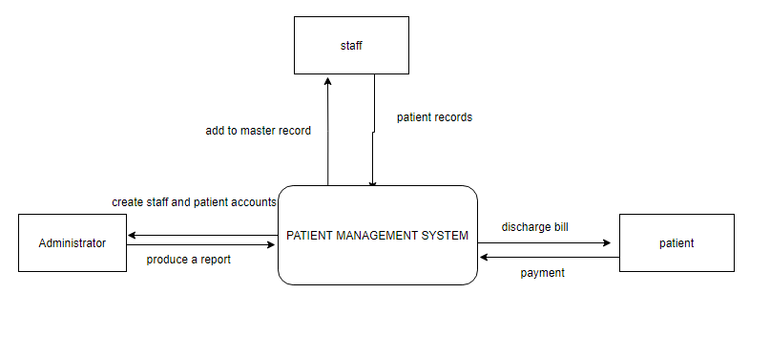

Figure 9: Context level Diagram

**4.3.1** Use case diagram

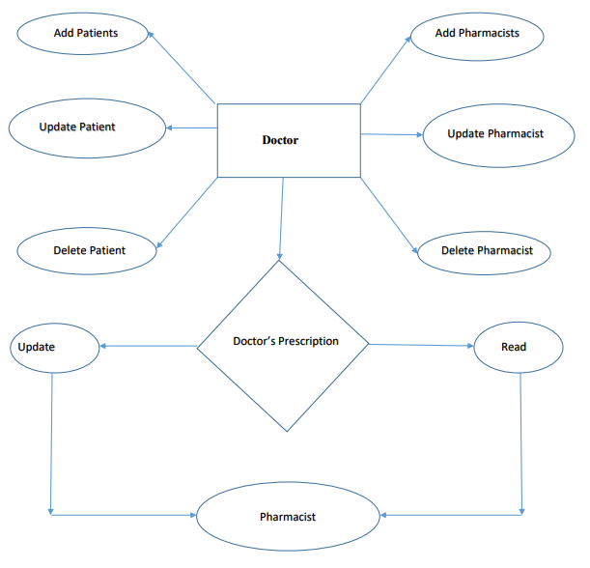

Figure 10: use case diagram

**4.3.2** Sequence diagram

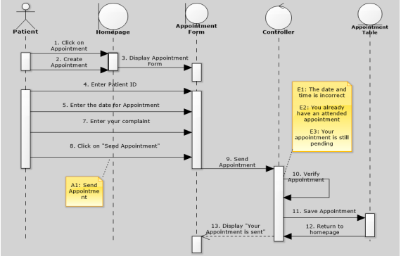

Figure 11: sequence diagram.

**4.4** System analysis

After carefully analyzing the requirements and functionality of the web application, I have two important diagrams by the end of the analysis phase. They are the ER diagram and data flow diagram which are the basis for finding out entities and relationships between them and the flow of information.

**4.5** Database design

A database is a file composed of records, each containing fields together with a set of operations it helps in organizing data in a logical order for references. Database design is the process of producing a detailed data model of a database and for us to come up with the best database model.

The database contains related data which are organized together in a group of object, table, and file it can be informed of a node. In this project, a relational database concept was used in this appraisal, and related data was stored or organized in a different table. The database design of this system is as shown

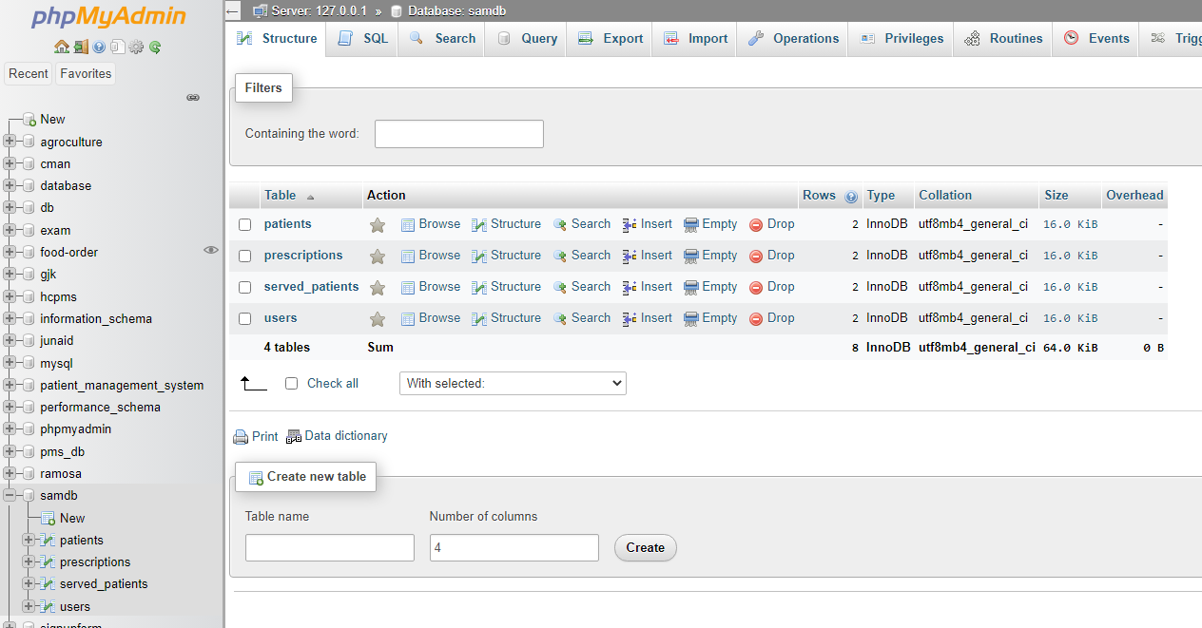

**Users table details**

|  |  |  |  |  |  |
| --- | --- | --- | --- | --- | --- |
| NAME | TYPE | SIZE | DESCRIPTION | KEY | DEFAULT VALUE |
| ID | varchar |  | Id if the user | Primary key | Not Null |
| Name | varchar | 45 | Name of the user | Foreign key | Not Null |
| Email | varchar | 100 | Email of the user | Foreign key | Not Null |
| Role | varchar | 50 | Role number of the user, either a doctor or a pharmacist | Foreign key | Not Null |
| Password | varchar | 100 | Qualification of the user | Foreign key | Not Null |
| Profile photo | varchar | 255 | Profile photo of the user | Foreign key | Not Null |

**Patient table details**

|  |  |  |  |  |  |
| --- | --- | --- | --- | --- | --- |
| NAME | TYPE | SIZE | DESCRIPTION | KEY | DEFAULT VALUE |
| Patient id | Integer | 20 | Id of the patient | Primary key | Not Null |
| Name | Varchar | 40 | Name of the patient | Foreign key | Not Null |
| Email | Varchar | 60 | email of the patient | Foreign key | Not Null |
| Gender | Varchar | 90 | Gender of the patient | Foreign key | Not Null |
| Address | Varchar | 45 | Address of the patient | Foreign key | Not Null |
| Date of birth | Datetime | 50 | Date of birth of the patient | Foreign key | Not Null |
| Weight | varchar | 255 | Weight of patient in kg | Foreign key | Not Null |
| Blood type | varchar | 100 | Blood group type of the patient | Foreign key | Not Null |
| Contact Number | Integer | 90 | Contact number of the patient | Foreign key | Not Null |

**prescriptions details**

|  |  |  |  |  |  |
| --- | --- | --- | --- | --- | --- |
| Name | Type | Size | Description | KEY | DEFAULT VALUE |
| Id | Integer | 30 | Id of the patient table | Foreign key | Not Null |
| Patient name | Varchar | 20 | Name of the patient | Foreign key | Not Null |
| Patient id | Varchar | 25 | Id of the patient | Primary key | Not Null |
| Symptoms | Varchar | 50 | Symptoms revealed by the doctor | Foreign key | Not Null |
| Drugs | Varchar | 50 | Medicine to be given to the patient | Foreign key | Not Null |
| Doctor name | Varchar | 50 | Name of the doctor who attended to the patient | Foreign key | Not Null |
| Post time | Datetime | 100 | Time when prescriptions was posted | Foreign key | Not Null |

**Served patient details**

|  |  |  |  |  |  |
| --- | --- | --- | --- | --- | --- |
| Name | Type | Size | Descriptions | Key | Default value |
| Id |  | 20 | Number of the patient when served | Primary key | Not Null |
| Patient name | Varchar | 255 | Name of the patient | Foreign key | Not Null |
| Patient email | Varchar | 255 | Email of the patient | Foreign key | Not Null |
| Patient phone | Varchar | 10 | Phone number of the patient | Foreign key | Not Null |
| Patient weight | Varchar | 100 | Weight of the patient | Foreign key | Not Null |
| Blood type | Varchar | 100 | Blood group of the patient | Foreign key | Not Null |
| Gender | Varchar | 200 | gender of the patient | Foreign key | Not Null |
| Admission date | Datetime | 50 | date when the patient was admitted | Foreign key | Not Null |
| Admission time | Datetime | 100 | time when the patient was admitted | Foreign key | Not Null |

**4.6** Conclusion

This chapter has specified the design of a patient management system. The aspect of the design that have been discussed are system design, process design, interface design, and database design by providing the context diagram, sequence diagram, use case diagrams and ERD. The various designs ranging from the input design to the output design ensure the timely completion of the implementation process.

# CHAPTER FIVE: SYSTEM TESTING AND IMPLEMENTATION

## 5.1 Introduction

This chapter deals with the implementation and testing of the system. It clearly explains how major functionalities and the system were implemented and the implementation environment as it was done. Testing is a critical aspect of system development hence different types of testing were done to ensure the correctness of the system.

## 5.2 System implementation

**5.2.0** Implementation requirements

|  |  |
| --- | --- |
| Language used | Html, css, JavaScript, MySQL database, php |
| coding software | Visual studio code |
| Database used | XAMPP |
| Local server used | XAMPP |
| Changeover method | Parallel |

**5.2.**1 login module

This login module was designed as a gateway for the system admin, patients, doctors and other members of a hospital or a health center to log into the system. They are required to submit their login credentials to access their dashboard.



**5.2.2** Registration module

Developing a system that registers new members was one of my objectives. This is achieved by developing and implementing a module on the admins side that captures

member’s details.



### 5.3 System testing

This particular subchapter is dedicated to performing testing to access the efficiency and effectiveness of the patient management system functionalities. This chapter is regarded as one of the most significant chapters in system development as it conducts and performs the final system testing to checkmate errors and mistakes and to ensure that the newly developed system functionalities meet the initial requirements to prevail over the problems in the current system. So before the system reach the hands of its users. This testing is to be carried out to ensure that the system satisfies its requirements and solves the problem for which it is being developed to solve

Testing techniques are:

1. Unit testing
2. Integration testing
3. System testing
4. Acceptance testing

**5.3.1** Unit testing

Unit testing emphasizes the verification effort on the smallest unit of software design i.e.; a software component or module. Unit testing is a dynamic method for verification, where program is actually compiled and executed. Unit testing is performed in parallel with the coding phase. Unit testing tests units or modules not the whole software. I have tested each view/module of the application individually. As the modules were built up testing was carried out simultaneously, tracking out each and every kind of input and checking the corresponding output until module is working correctly. The functionality of the modules was also tested as separate units. Each of the modules was tested as separate units. In each module all the functionalities were tested in isolation. Methods were written to retrieve all the patients from the database, strings that match a certain search service and activities that match certain filter criteria. Unit test cases were automatically generated for these methods.



**5.3.2** Integration testing

In integration testing a system consisting of different modules is tested for problems arising from component interaction. Integration testing should be developed from the system specification. Firstly, a minimum configuration must be integrated and tested.

In my project I have done integration testing in a bottom-up fashion i.e., in this project I have started construction and testing with atomic modules. After unit testing the modules are integrated one by one and then tested the system for problems arising from component interaction.

**5.3.3** System testing

System provides final assurances that software meets all functional, behavioral & performance requirement. This testing is undertaken to ensure that the various modules of the system are well integrated to form a complete working system. All the modules were integrated successfully and outputs were successfully generated as expected. I have used a number of test cases for testing the product. There were different cases for which different inputs were used to check whether desired output is produced or not. The admins and members dashboard, the log-out and log-in modules were all integrated forming the complete patient management system which worked perfectly.

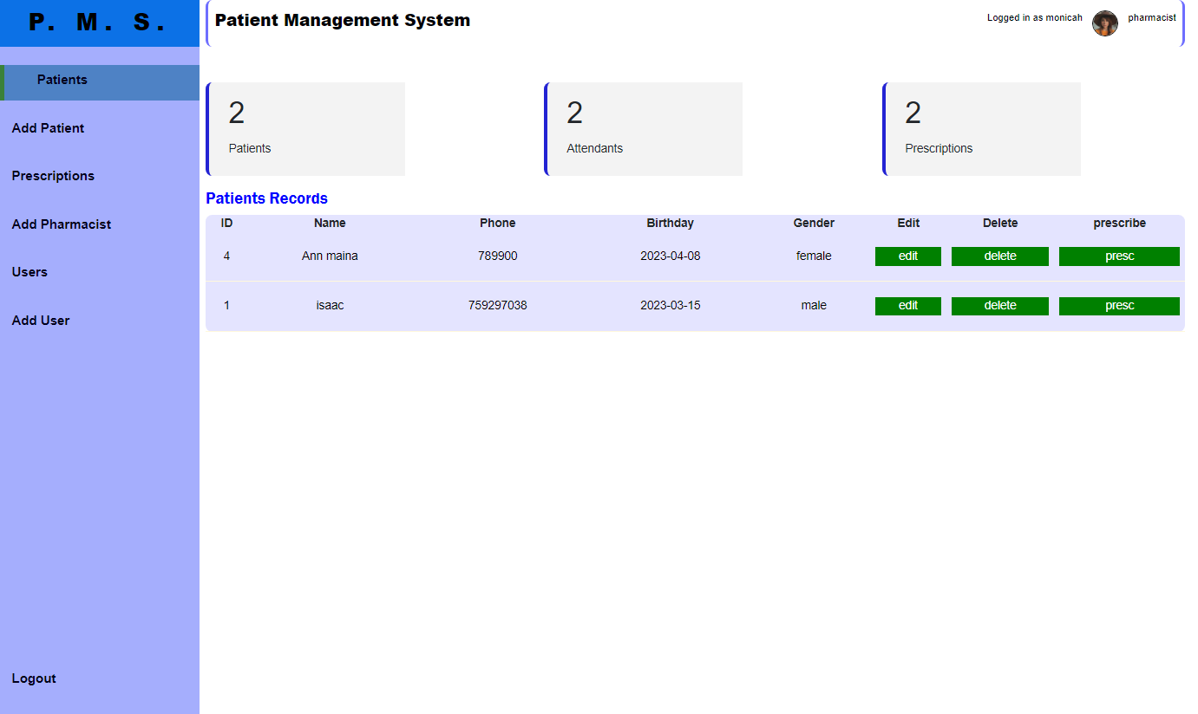

**5.3.4** Acceptance testing

Acceptance testing was used to assess whether or not the final piece of software was ready for delivery. It involves ensuring that the product was in compliance with all of the original business criteria and that it meets the end user’s needs. Upon completion of testing and deployment, the system was released to different patients and doctors in hospitals and medium health centers to interact with the system. They later gave a feedback on the same that the system was helpful to them and would be of great advantage to them since its simple and less tiresome for it allowed computerized storage of their recordings instead of the manual work they did before.

### 5.3.5 Database testing

After developing the system, I did a software test of the schema, tables, and triggers of the database to check its responsiveness, integrity, and consistency of the data. Testing was done on various database functionalities such as editing, deleting, and inserting all were possible. This is a clear indication that the system database is working well.



**5.**4 user manuals

This is a guide that helps the system users how to access and navigate the patient Management System. The system has been packaged in CD-ROM and can be hosted on a web server like any other website in the market.

**5.**5coding tools

Patient Management System will use the following coding tools;

XAMPP SOFTWARE- It will be used to create database tables, alter the tables, inserting data into the table. It is also required in the running of the project by starting Apache and MYSQL

VISUAL STUDIO CODE- It is a software that will be used in coding the codes

BRAVE BROWSER -It is a running environment that will be used in running the project.

# 5.6 System homepage and other relevant pages

## 5.6.0 Home page

After a successful login the doctor and the pharmacist gets to the homepage.



## 5.6.1 Login page



## 5.6.2 Sign up page



## 5.6.3Add new patient page

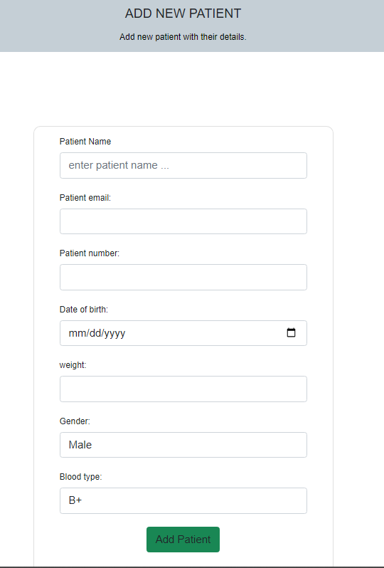

## 5.6.4 Systems side bar

On the side bar there is patient, add patient, prescription, served patients and users of the website.

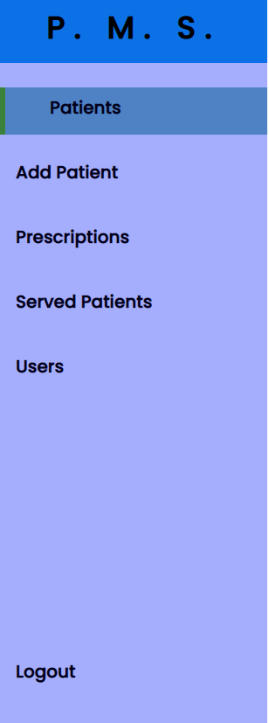

## 5.6.5 Patients

On the sidebar it contains the patients who have been registered and who are waiting to be attended to by the doctor.

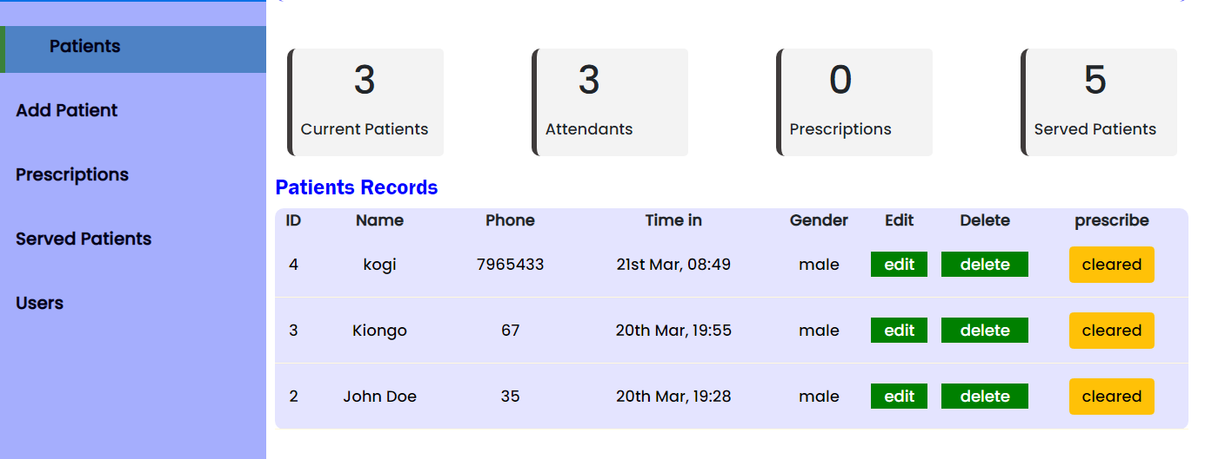

## 5.6.6 Served patients

On the sidebar it contains the number of patients who have been attended to by the doctor. The patient maybe waiting for the pharmacist to attend to the prescriptions given by the doctor.

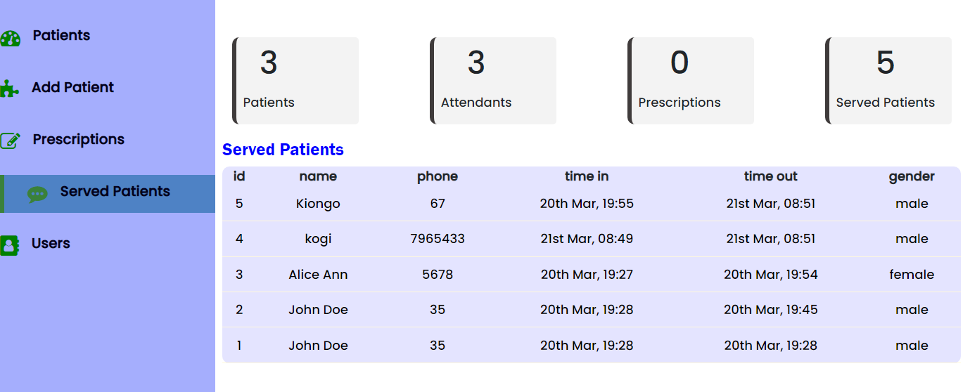

## 5.6.7 Users

On the users page you will find the people who manages the system and still a new user can be added in the system

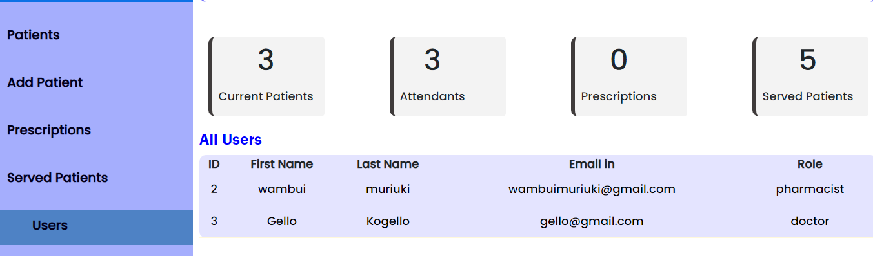

# 5.7 **Conclusions**

The chapter covered different types of testing that were done, the different units in the system and the implementation requirements. All testing was conducted successfully and some errors and bugs found were immediately fixed. The website application can be used for any middle level and big health centers and hospitals. It is easy to use, since it uses the GUI provided in the user dialog. User friendly screens, different navigations and different tabs are provided. The application is easy to use and interactive making medical services and treatment an easy activity for users. It has been thoroughly tested and implemented.

# CHAPTER SIX CONCLUSSIONS AND RECOMMENDATIONS.

## 6.**0 Introduction**

After successful build, test and functionality trial of the system, it can now be validated to perform stated objectives but with limitations stated and scope for future work which will help make the system’s functionality even more I interactive

## 6.1 **Conclusion**

The project patient management system is for computerizing the working in a medical center and hospitals. It is a great improvement over the manual system. The computerization of the system has speed up the process and different activities in a hospital. In the current system, the front office managing is very slow. The Patient managing system was thoroughly checked and tested with dummy data and thus is found to be very reliable. The software takes care of all the requirements of an average hospital and is capable to provide easy and effective storage of information related to patients that come up to the hospital. It generates test report and also provides the facility for searching the details of the patient.

## 6.2 Recommendation

The proposed system is Patient Management System. We can enhance this system by including more facilities like pharmacy system for the stock details of medicines in the pharmacy. Providing such features enable the users to include more comments into the system.

## 6.3 Scope for future work

The proposed system is Patient Management System. We can enhance this system by including more facilities like pharmacy system for the stock details of medicines in the pharmacy. An advanced password system, hosting of the system using different ip addresses and also the system can be improved to be sending sms alerts to the patients some day before the appointment date and time can be reached. Providing such features enable the users to include more comments into the system.

**References**

Al-Sharhan, S., Omran, E., & Lari, K. (2019). An integrated holistic model for an eHealth system: A national implementation approach and a new cloud-based security model. *International Journal of Information Management*, *47*, 121-130.

Mahmudova, N. (2019). The Importance of Using Database Management Systems in Hospitals.

Salomi, M. J. A., & Maciel, R. F. (2017). Document Management and Process Automation in a Paperless Healthcare Institution. *Technology and Investment*, *8*(3), 167-178.

Equityafia.co.ke. (n.d.). Retrieved January 10, 2022, from https://www.equityafia.co.ke/about-us/

Actualize. (2021, January 8). *Actualize*. Integra LLC. Retrieved January 10, 2022, from https://www.integrallc.com/mobile-health-app-launched-in-kenya-will-increase-access-to-healthcare-information-2/

*About Us*. AfyaServe. (2020, May 5). Retrieved January 12, 2022, from https://www.afyaserve.com/about-us/

*24/7 virtual visits & answers with U.S. doctors*. HealthTap. (n.d.). Retrieved January 12, 2022, from https://www.healthtap.com/

*About us - vezeeta.com*. (n.d.). Retrieved January 12, 2022, from <https://www.vezeeta.co.ke/en/Generic/AboutUs>

*Online doctors and free symptom checkups*. byon8. (n.d.). Retrieved January 12, 2022, from https://www.byon8.com/

Kumar, R. (2018). *Research methodology: A step-by-step guide for beginners*. Sage.

Kramer, M. (2018). Best practices in systems development lifecycle: An analyses based on the waterfall model. *Review of Business & Finance Studies*, *9*(1), 77-84.

Nur Hidayati, S. (2020). Application of Waterfall Model In Development of Work Training Acceptance System.

Kyeremeh, K. (2019). Overview of System Development Life Cycle Models. *Available at SSRN 3448536*.

Barrett, D., & Twycross, A. (2018). Data collection in qualitative research. *Evidence-Based Nursing*, *21*(3), 63-64.

Fan, K., Wang, S., Ren, Y., Li, H., & Yang, Y. (2018). Medblock: Efficient and secure medical data sharing via blockchain. *Journal of medical systems*, *42*(8), 1-11.

Arasteh, M. A., Shamshirband, S., & Yee, P. L. (2018). Using multi-attribute decision-making approaches in the selection of a hospital management system. *Technology and Health Care*, *26*(2), 279-295.

Lubrano, F., Stirano, F., Varavallo, G., Bertone, F., & Terzo, O. (2020, July). HAMS: an integrated hospital management system to improve information exchange. In *Conference on Complex, Intelligent, and Software Intensive Systems* (pp. 334-343). Springer, Cham.

Nugraheni, W. P., Zahroh, A. H., & Hartono, R. K. (2021). BEST PRACTICE: HOSPITAL MANAGEMENT STRATEGY TO THRIVE IN THE NATIONAL HEALTH INSURANCE (JKN) ERA. *Jurnal Administrasi Kesehatan Indonesia*, *9*(1).

# Appendices

## Budget

|  |  |  |  |  |
| --- | --- | --- | --- | --- |
| **ITEM** | **DESCRIPTION** | **QTY** | **UNIT PRICE** | **AMOUNT** |
| Hardware | Laptop | 1 | 20000 | 20000 |
|  | Flash disk | 1 | 1000 | 1000 |
| Software | Ms Access | **-** | Free | - |
|  | Visual code | **-** | Free | - |
| Others | Printing/stationery | **-** | 600 | 600 |
|  | Miscellaneous | **-** | 10000 | 10000 |
| Total |  |  |  | 31600 |

## Gantt chart

|  |  |  |  |  |  |  |  |  |
| --- | --- | --- | --- | --- | --- | --- | --- | --- |
| **Schedule**  **Activity** | **September** | **October** | **November** | **December** | **January** | **February** | **march** | **April** |
| Title selection |  |  |  |  |  |  |  |  |
| Proposal writing |  |  |  |  |  |  |  |  |
| Proposal Presentation |  |  |  |  |  |  |  |  |
| Requirement gathering |  |  |  |  |  |  |  |  |
| Design |  |  |  |  |  |  |  |  |
| Construction |  |  |  |  |  |  |  |  |
| Testing |  |  |  |  |  |  |  |  |
| Deployment |  |  |  |  |  |  |  |  |
| Feedback |  |  |  |  |  |  |  |  |



